HOSTED BY
[HOST LOGO]
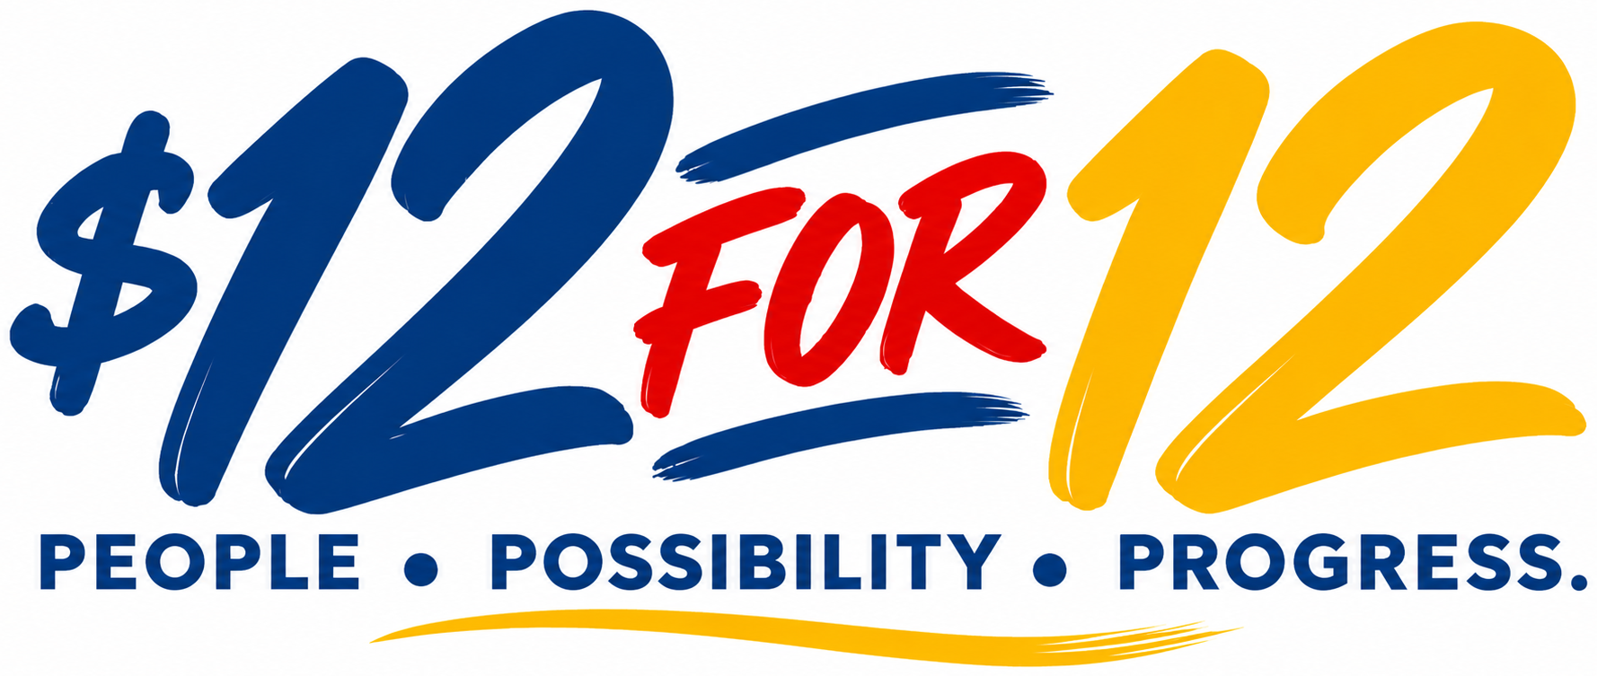
[UNITED BEFORE BREAKFAST / UNITED LUNCH & LEARN / UNITED AFTER HOURS / OTHER]
ONE COMMUNITY. ONE VOICE. ONE IMPACT.
[DATE]
[TIME]
[HOST ORGANIZATION]
[LOCATION]

TOGETHER WITH OUR COMMUNITY PARTNERS
 | 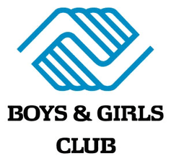 |  |  | 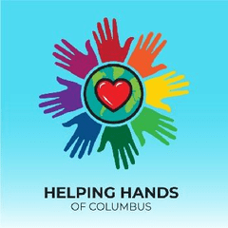 | 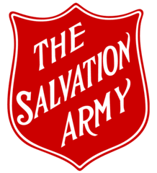 | 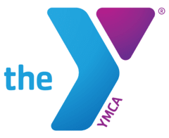
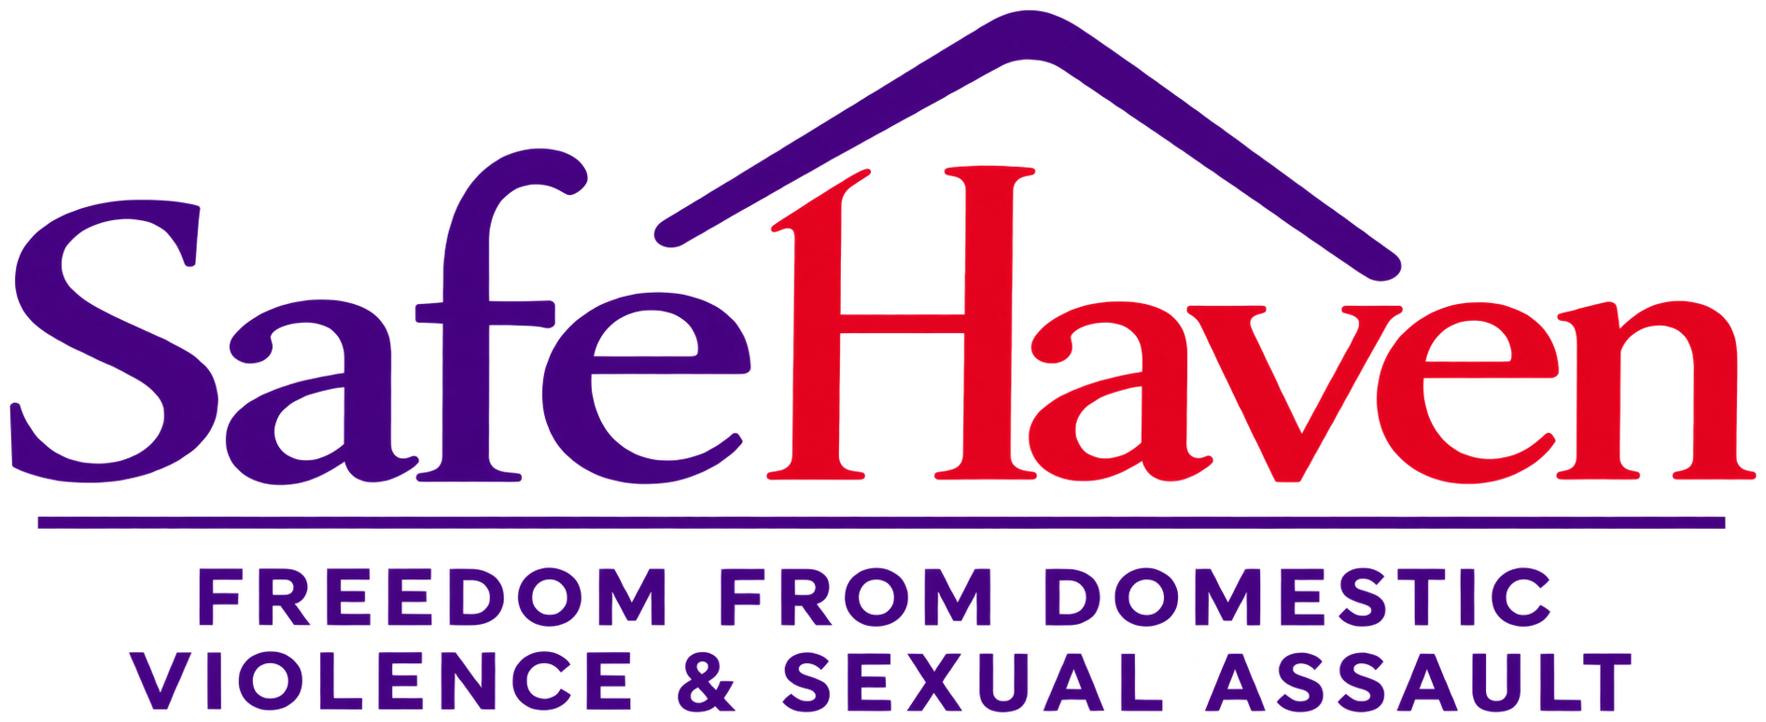 |  |  | 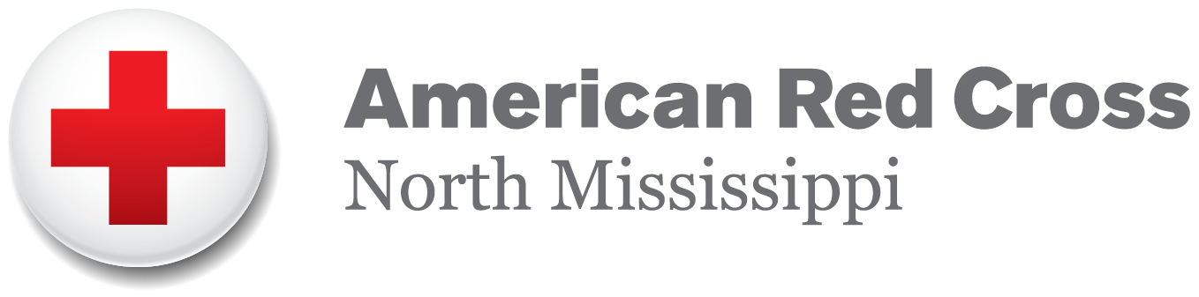 | 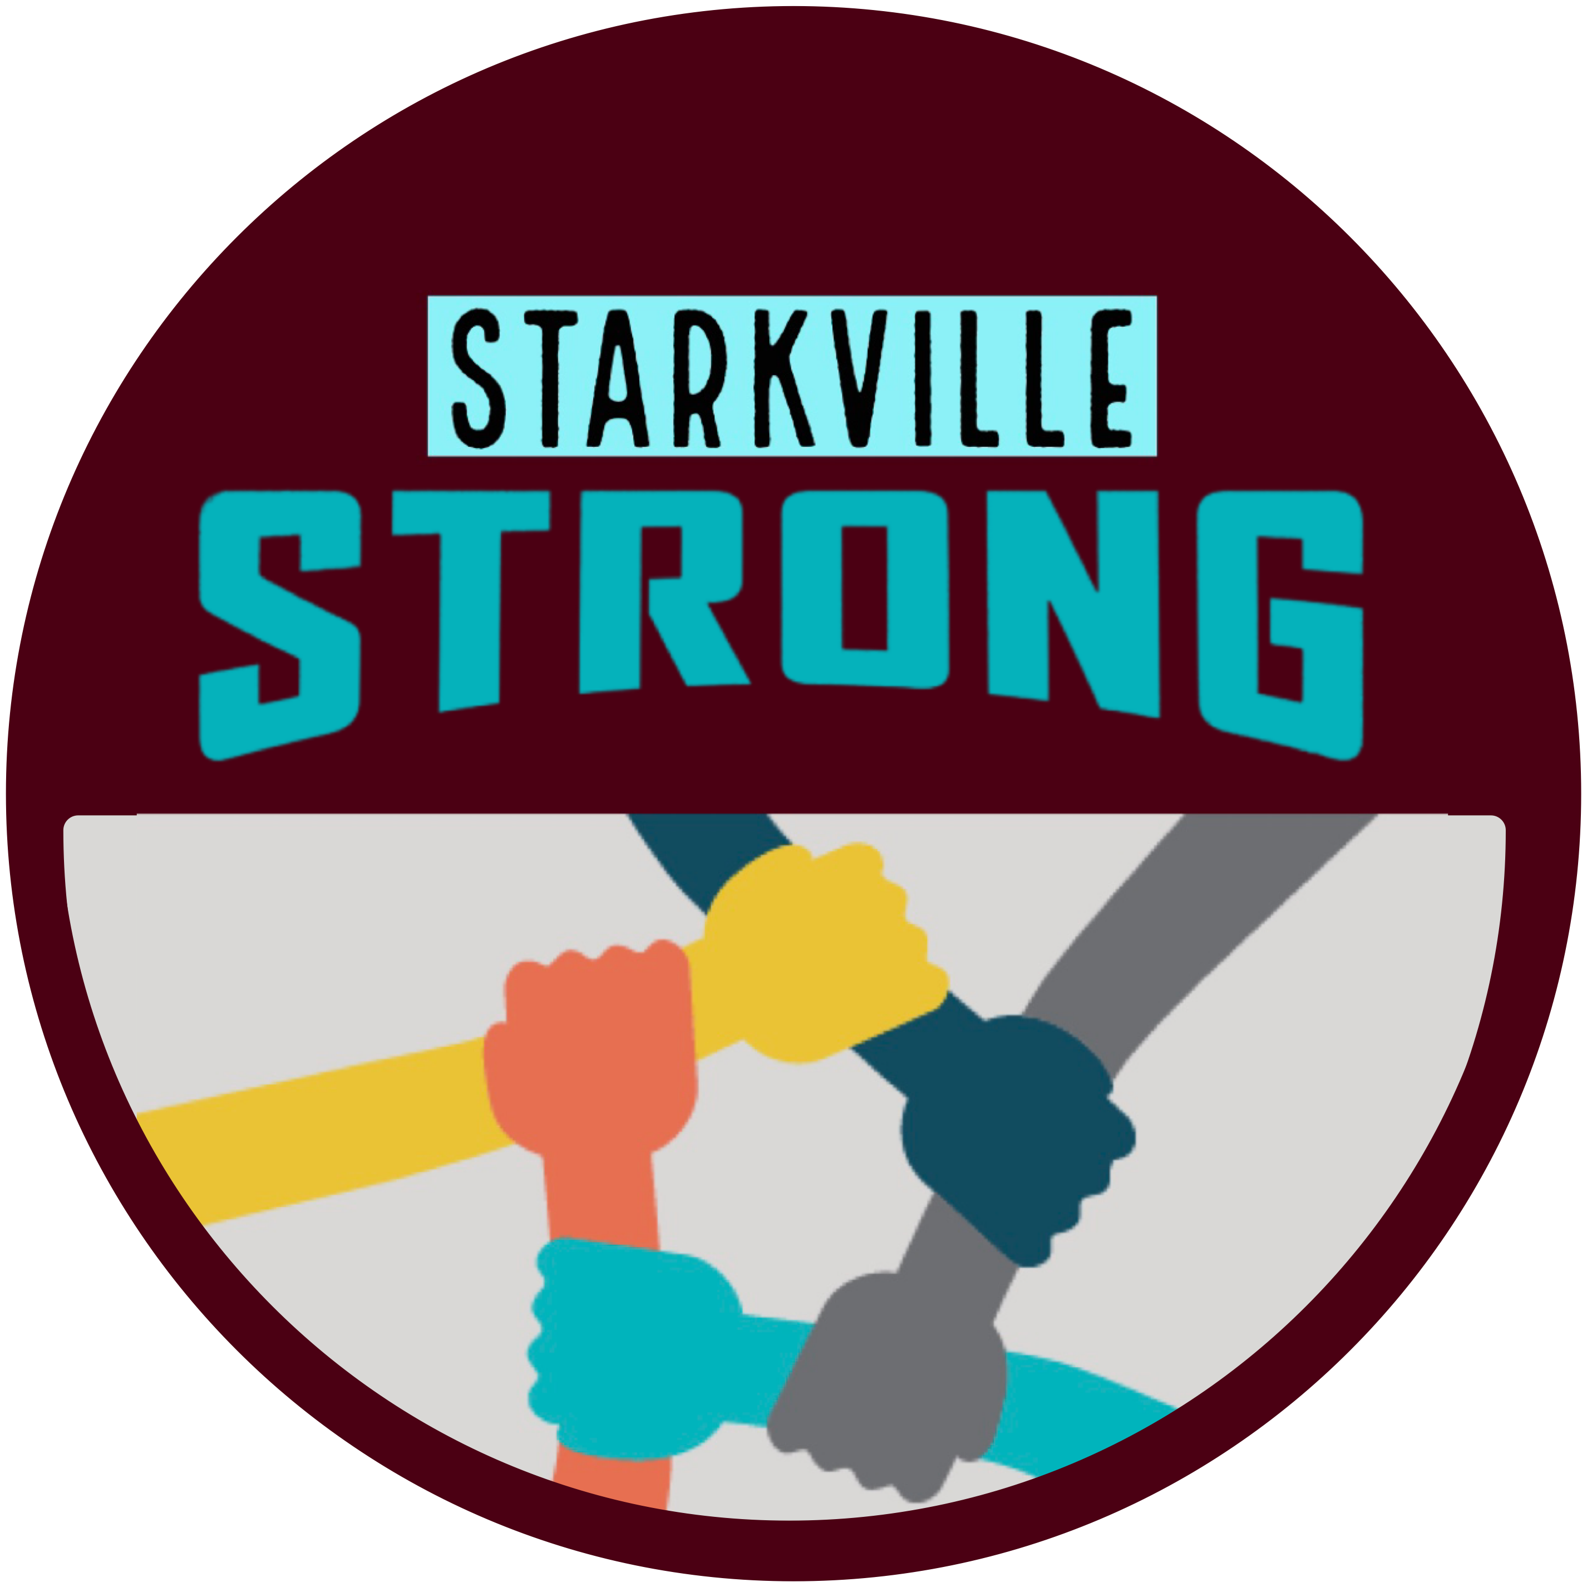 | 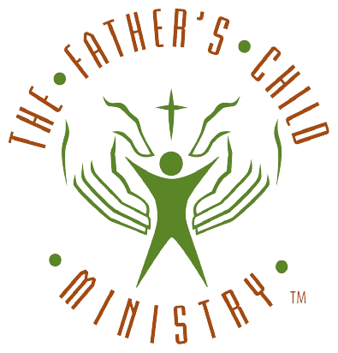 | 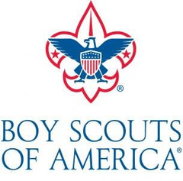

COME CONNECT. HEAR THE STORY. BE PART OF WHAT HAPPENS NEXT.
Join us for an hour of connection, conversation, and community impact. Meet the local agencies working together across our region and discover how you can be part of something greater.
CONNECTION • COMMUNITY • DOOR PRIZES • LOCAL IMPACT
EDIT ONLY THE BRACKETED FIELDS ABOVE. KEEP 12 FOR 12 CAMPAIGN BRANDING IN PLACE.

